Shabbos Stories for
Parshas chaya sarah 5774
Volume 5, Issue 9 22 Cheshvon 5774/ October 26, 2013
For a free subscription, please forward your request to keren18@juno.com

It Once Happened

The Legendary
Transylvania Converts

About 600 years ago a religious movement began in Transylvania whose adherents, although not Jewish, observed certain Jewish commandments. In addition to keeping the Sabbath and the laws of kashrut, they celebrated Passover and had their own prayer book, an almost literal translation of the Jewish siddur into Hungarian.

Persecuted, Imprisoned and Even Killed
For many years the group was persecuted and its leaders imprisoned, tortured and even killed. Some of its members escaped to Turkey, where they formally converted to Judaism. The most bloodthirsty enemy of the "Sabbath Observers," as they were called, was Queen Maria Teresa, who was known for her hatred of anything Jewish. Nonetheless, the sect stubbornly held on to its beliefs.
In the times of Kaiser Franz Josef the members of the sect underwent mass conversion and became full-fledged Jews. The following was written by a Jewish journalist who visited their village shortly before the outbreak of World War II:

Praying with Great Devotion
"We entered the converts' synagogue. There we found a congregation consisting of a few dozen men praying the afternoon service, reading intently from small prayer books. Their appearance is dignified and serious, and they pray with great devotion. The person who led the service appeared to be the embodiment of the words, 'Know before Whom you stand.' These were never common people, as their lineage goes back over 1000 years to the founding of Transylvanian society. Today, however, they all have long beards and long side curls...
"At the end of the service they clustered around us and gave us a hearty 'Shalom Aleichem.' It did not take long until the conversation turned to a subject that is obviously very dear to them, their conversion to Judaism. This story is a glorious chapter in their history, and they do not conceal their pride in their ancestors' decision, in the times of Franz Josef, to join the Jewish people...

Even the Old Men Willing
Underwent Brit Mila
"'And not only that,' they add modestly, 'many of our forefathers were already quite old when they willingly underwent the mitzva of brit mila (circumcision). Surely that in itself is no trifling matter!'
"As they tell it, the first member of their group to be circumcised was over 60 years old. He insisted that the Rabbi and the mohel (ritual circumciser) promise that if he died during the procedure, they would bury him as a Jew. In fact, everyone was clamoring to be circumcised first, as they all wanted to become Jewish as soon as possible. Even the youngsters were impatient...
"The new Jews suffered greatly because of their faith, but to them, all the pain and anguish was welcome. 'We knew that we had done a great thing,' they say, 'and we waited patiently for the reaction of the non-Jewish community.'

Ordered to Assemble
At the Courthouse
"The reaction was not long in coming. 'We were ordered to assemble at the courthouse. We were not afraid. We thought, what could do they do to us? Put us in jail? Our ancestors had also been imprisoned. Maybe we would be forced into the very same cells...'
"The date of the court appearance arrived. Everyone in the entire village put on his finest Sabbath clothing ...
"The chief magistrate turned to an elderly gentleman and demanded to know what had gotten into his head. The man replied that as his family had already been observing the Sabbath and eating kosher for several hundred years, the time had come to complete the process and not be satisfied with halfway measures.
The judge then asked if anyone had felt compelled or coerced to convert, to which they all answered no, they had become Jews of their own free will. The judge then declared that he would announce his verdict in two days. The fledgling Jews were ready to accept whatever punishment he decreed...
"Two days later the verdict was announced: Whoever wished to remain a Jew would be obligated to turn over all his property to the royal treasury!
"A vast sigh of relief filled the courthouse. That was to be their punishment? Joyfully they went home and returned to the courthouse with all of their cows and oxen, jewelry and fine clothes. Everything was piled into a huge mound in front of the building.

The Judge Was Impressed
The judge, who had been watching the proceedings, then declared, 'In the name of the Kaiser Franz Josef, you are hereby granted permission to embrace your new faith. I just wanted to see how much you were willing to sacrifice on behalf of your beliefs...' "
For the next 75 years the community flourished. Jews from the surrounding areas built them a synagogue, and sent them a Rabbi and a shochet (ritual slaughterer) to attend to their needs.
Unfortunately, the Holocaust perpetuated by the Nazis, may their name be erased, did not leave these righteous converts unscathed. When the time came they entered the ghettoes and concentration camps with the rest of their brethren, where they publicly sanctified G-d's Name.

Reprinted from this week’s email of “L’Chaim,” a publication of the Lubavitch Youth Organization in Brooklyn, NY.
Tales of the Gaonim

Rav Naftali Of Ropshitz
By Rabbi Sholom Klass

Galicia was able to boast of having three giants of the Chassidic movement who lived at the same period of time. They were Rav Meir of Premishlan, Rav Tzvi Hirsh of Rimenov and Rav Naftali of Ropshitz. The latter, especially, was famous for the sharpness of his mind.
His father, Rav Menachem Mendel, the rebbe of Liska, had married the daughter of the gaon Reb Yitzhak Halevi Horowitz, spiritual leader of the great Torah center of Altona and Hamburg, who was, ironically, one of the staunchest misnagdim (opponents of Chassidism). Yet, it was his grandson who was to become one of the leaders of the Chassidic movement.
Rav Naftali was born the day that the Baal Shem Tov passed away, on the holiday of Shavuos, in the year 5520. He was not only a Chassidic rebbe but also a great Torah scholar with both sharp mind and wit – traits he inherited from his father, Rav Menachem Mendel.

As A Child
The cleverness of the great Rav Naftali was apparent to all, even as a young child. It was the custom in Galicia that on the night before a bris milah the evening was set aside as Leyl Shemurim and all the little children would come to the home of the newborn child and say the Shema. Following this, they would all be given candy and other sweets.
One day, a bris was to be held in a certain house in Liska, and little Naftali and the other youngsters hurried over. They all said the Shema and Naftali said it with great fervor and in a loud voice.

Extra Portion
Later, the father gave out sweets to the children and wanted to give Naftali a double portion. But the little boy refused, saying, “My father taught me that a person should never show preference to one boy over the others since this leads to jealousy.”
After a few moments, however, when all the portions had been handed out, Naftali came over to the man and asked for a second piece.
“What is this?” asked the man. “I offered you a double portion before and you refused. Now, why did you change your mind?”
“I did not change my mind,” answered the little boy. “Before,when you were giving out the portions, I thought that only one child had been born. I just learned that there were twins, so this calls for a double share for everyone.”

Reprinted from last week’s edition of The Jewish Press.

A Moment with Rabbi Avigdor Miller, Zt”l
A Negative Self Image

QUESTION:
What should a person do who has a negative self image?

I should say, mazal tov, I congratulate you! You're an anav.

There's only one problem here: You have to be satisfied that you have such an image. If you're dissatisfied then it's a pity on you. Then you have an inferiority complex.
It means you want to be somebody big in the world, you're jealous of others and that worries you/. But if you have a negative self image and you're happy about it, then you're mekayim vnafshi ka'ofor lakol thiye, you're an anav [humble person] and Hakadosh Baruch Hu will give you success just because you're an anav.
The Chovos Halvavos says an anav is more capable of receiving wisdom. Kesher tefilin herah, to whom did Hashem show all the things? To an anav, Moshe Rabeinu, because he was an anav. But you have to learn how to be satisfied with that role. But if you're going to be moody and depressed because of your negative self image then you don't have a good self image at all.
You have an image that you think you're somebody, you want to be somebody more than you really are. Therefore you have to start relearning the values of life. The values of life are, to learn how to utilize life to make the best you can out of yourself and not worry about what you are not, worry what you could be. On all sides opportunities are waiting.
Suppose they let you into a safe for five seconds where there are diamonds, and you only have five seconds to pick diamonds. Instead you’re standing and worrying, maybe I won't pick enough diamonds, maybe I'll pick the wrong diamonds. Before you know it the time is up and the man behind the safe is pulling you out by your feet. Time is up.
So don't worry, start picking diamonds right away, grab whatever you can. Therefore this world is not made for worrying, it's made for achieving.

Reprinted from last week’s email of “A Moment with Rabbi Avigdor Miller, zt”l” that is based on a transcription of Rav Miller’s answer to a question posed at one of his classic Thursday night hashkafa lectures at his Flatbush shul (circa 1970s -2001.)

On Savile Row,
A Rabbi Hones His Craft
By Amy Guttman|

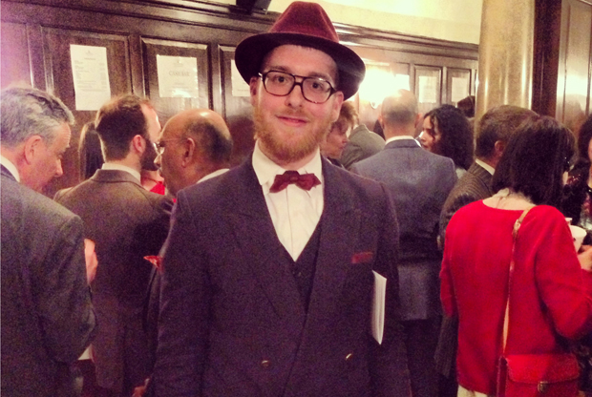
An apprentice tailor, Yosel Tiefenbrun mixes the sartorial with the spiritual
It’s not every day that a rabbi gets photographed by a GQ editor, kicking off a flurry of media attention after his on-trend ensemble appeared on Instagram. But 24-year old Londoner Yosel Tiefenbrun isn’t your typical rabbi. When the Chabadnik isn’t filling in for rabbis or serving as a cantor in his father’s synagogue, he’s welcoming customers to a 75-year-old tailoring house on Savile Row or bent over a sewing machine in the back of the shop.
Born in Brooklyn, NY, Tiefenbrun moved to London as a child, where his obsession with style began at an early age. “When I was a little boy, we used to get suits before the High Holidays and Pesach,” he told me. “I used to really take care of them to make sure they were perfect, my shoes were shined. I didn’t want even a scratch on them.”
“I always dreamt as a child of having my own brand,” he added.

A Devout Lubavitcher Born to be a Rabbi
Tiefenbrun’s story has the usual beginning, born to a rabbi, raised to be a devout Lubavitcher, attending yeshiva in New York, Israel, and France. After his ordination, Tiefenbrun spent two years working as a rabbi in Singapore. During that time, he balanced rabbinical work with an interior design course to pursue his passion—or at least a form of it.
“I thought for a religious Jew it might be difficult to enter fashion school, so I tried interiors,” he explained. “But I realized I was incorporating fashion into my drawings.”
As the eldest child, Tiefenbrun’s foray into fashion wasn’t immediately embaced by his parents, but after a while, as he says, “they got used to it.” He went on to learn how to sketch before returning to London, one of the greatest cities for apparel design and craftmanship. But knocking on the doors of Savile Row wasn’t so easy.

Run by Englishmen with Long Family Histories
Though there are a handful of more recent arrivals, most of the tailoring houses with the famous address have been around for hundreds of years—and unlike New York’s Lower East Side in the 19th and 20th century, they’re run by Englishmen with long family histories, not enterprising immigrants. This traditional environment combined with the effects of the recession and the obligatory wages firms must pay trainees makes an apprenticeship a prized possession.
Enter Andrew Ramroop, a Trinidadian master cutter who came to London more than 40 years ago, having never travelled further than a few miles from where he grew up. Like Tiefenbrun, he tried to break through the largely cloistered world of London’s established tailoring houses. Even with years of experience, he struggled to get a foot in any door—until he met Maurice Sedwell. The English tailor had travelled extensively during World War II as an army officer and returned to London with an open mind. Sedwell gave Ramroop the chance that would change his life.
“I was turned down for just about every job, even with nine years of experience,” Ramroop explained. “I had a funny accent, my hair grew high, curly and bushy. Employers are afraid of letting anyone in that they feel their customers might not take kindly to.” Status, it seemed, trumped skill. “Even in this century, I was offered backroom jobs only, despite have glowing qualifications,” he said. “Maurice Sedwell is the only one who gave me a job.” Ramroop would also become the person Sedwell sold his business to when he eventually retired in 1988.

Ramroop Saw a Uniqueness in Yosel
Ramroop now owns Maurice Sedwell and runs the Savile Row Academy, ushering in a new generation of finishers, cutters, and fitters. He saw something in Tiefenbrun and broke with traditional academy policy, offering the rabbi an apprenticeship at Maurice Sedwell even before he graduated.
“Yosel is unique, that’s his value,” Ramroop told me. That unique style is what got Tiefenbrun noticed by GQ’s online fashion editor Nick Carvell at London’s Golden Shears awards in May. The industry event happens every two years, and Tiefenbrun went by chance after a colleague backed out at the last minute. He wasn’t up for an award, but he earned a serious distinction when Carvell posted his noteworthy outfit on Instagram and Twitter.

Carvell was Impressed by
Tiefenbrun’s Curatorial Instincts
“I just thought he looked good,” Carvell explained. “His heritage helped him tick the beard trend, and his outfit looked really good.” It was Tiefenbrun’s curatorial instincts, though, and not his unusual background, that got Carvell’s attention. “I didn’t know anything about him, I just thought he dressed really impeccably,” Carvell added. “It was the combination of him wearing the on-trend claret color, which is going to be very big this season, and we don’t see a Trilby hat very often and he wore it well.”
Since then, the rabbi and his Trinidadian mentor have been courted by the British press. When asked whether Ramroop’s own struggle to break into the industry played a part in his decision to take Tiefenbrun on as a protégé, the master tailor simply smiles.
His tweets represent his carefully balanced life–by day practicing his trade, crafting suits worth thousands of dollars. He mingles with a rich sartorial history, dressing some of the world’s wealthiest people. By night he’s busy planning sermons and preparing for Shabbat services. And as Tiefenbrun explains, his focus on finery fits seamlessly with his respect for religion.
“Wearing beautiful clothing has always been important for the High Holidays,” he said. “You’re supposed to wear your best clothes when you’re praying; from your shoes to your hat, you’re supposed to wear something special.” Ramroop interjects: “It’s not just the Jewish religion, think of all those who wear their Sunday best to church.”
Clothes may complement the man, but in the refined, subdued elegance of Savile Row, the Trinidadian and Lubavitcher make a perfect pair.

Reprinted from the October 8, 2013 email of Tablet Magazine

The Golden Column
Rabbi Hayyim Ben Atar zs"l

Rabbi Hayyim Ben Atar zs"l, more commonly known by his work, the Or Hahayim, is one of the select few Torah giants who are generally referred to with the word "hakadosh" (the sacred) after their name. He was revered throughout all the communities of the Jewish people, from East to West. The following story is told about him, an episode which contains a critical lesson for us.
When he arrived in Yerushalayim, the Or Hahayim intensified his focus and concentration in his request that the redemption soon arrive. Next to his window stood a fig tree, which suddenly grew and shot forth enormous branches, producing an abundance of fruit. The tzadik was overjoyed, seeing this as a sign of blessing. He left his room and involved himself in his studies and meditation in the shade of the tree.

The Satan’s Great Feat
The Satan saw and feared his own demise with the arrival of the final redemption. He therefore lured the local children to climb up the tree and pick the fruits. All the commotion disrupted the Or Hahayim from his contemplation and the depth of his study. However, instead of rebuking the children he spoke with them gently, brought them inside and conversed with them, bringing them closer to the study of Torah.
The Satan realized that his plan was foiled, as the tzadik managed to turn the curse into a blessing. He therefore incited the neighboring gentiles to complain that the tree was blocking the sunlight from their homes. Besides simply registering their complaints, they secretly cut down the tree in the middle of the night.
This story appears in the books about his life and was handed down from father to son over the course of the generations. Imagine - the Satan feared that the deep concentration of the Or Hahayim would usher the redemption. At first, it seemed that his plan worked - the children did, in fact, interfere with the tzadik's thought. Apparently, though, when children are educated along the teachings of the Torah, the redemption is ushered in no less than through the sacred contemplation of the Or Hahayim zs"l!

Reprinted from the Parsha Lech Lecha edition of the Aram Soba Newsletter.

A Lesson to Be Learned
From Camels and Donkeys
By Rabbi Reuven Semah

“Then the servant took ten camels of his master’s camels.” (Beresheet 24:10)

When Eliezer, the devoted servant of Abraham Abinu, set out on his mission to seek a wife for Yitzhak Abinu, he took “ten camels of his master’s camels.” Rashi reveals to us what the Torah is teaching with the words “his master’s camels.” They were distinguishable from other camels by the fact that they would go out muzzled to prevent robbery so that they should not graze in strangers’ fields.

A Midrashic Question about
The Camels of Abraham
The Midrash wonders about this description of Abraham’s camels, because of a story involving Rabbi Pinhas ben Yair’s donkey. One night, robbers stole this donkey and took it to their hideout. After three days they finally released the donkey, and the donkey came home on its own. The donkey had not been fed for three days and was obviously starving. However, all efforts to feed the donkey failed, until the Rabbi was informed that the barley that the donkey was being fed was possibly demai. Demai is grain that there is a possibility that the ma’aser was not taken from it. Demai is permitted to give to an animal, but this animal was strict and didn’t want to be lenient.
How is it possible that Rabbi Pinhas ben Yair’s donkey is on a greater spiritual level than the camels of Abraham Abinu? If his starving donkey after three days of eating anything was so strict on himself that she refused to eat demai, why was it necessary for Abraham Abinu’s camels to wear a muzzle to make sure they wouldn’t steal from strangers’ fields?
The Nahalat Ya’akob answers that there was no reason to be concerned that camels belonging to Abraham would graze in others’ fields. The reason they were muzzled was so that others would see and learn from this righteous appearance, and muzzle their own animals as well.
The lesson is obvious. The Torah teaches that our animals must not steal. How much more careful do human beings have to be not to steal.

Reprinted from this week’s email of the Jersey Shore Torah Bulletin.
Flatbush Comes to Greet
Rabbi Yosef Mendelevich
By Daniel Keren

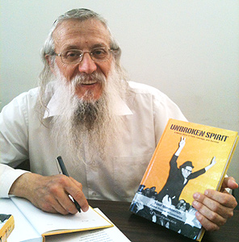
Rabbi Yosef Mendelevich
This past Motzoi Shabbos, hundreds of Jews from all over Flatbush and neighboring Brooklyn communities came to a special program highlighting Rabbi Yosef Mendelevich, the famous Russian refusnik (“Prisoner of Zion”) and true Jewish hero at the Young Israel of Flatbush. The event was also co-sponsored by Congregation Talmud Torah of Flatbush, the Young Israel of Avenue J, the Young Israel of Avenue K and the Young Israel of Midwood.

Recalling an Awakening of Their
Activism on Behalf of Soviet Jewry
For many in the audience the program was a nostalgic road back to their early teens and twenties some three of four decades ago when their ahavas Yisroel or love for fellow Yidden was awakened by the efforts of American activists to arouse other Jews and the United States government to help free the Prisoners of Zion and push the former Soviet Union to allow the hundreds of thousands of Russian Jews seeking religious and cultural freedom to emigrate to the State of Israel or other refuges in the West, including our own Kings County.
The program began with words from the mora d’atra of the host shul – Rabbi Kenneth Auman who noted similarities in last week’s parsha (Lech Lecha) with Avraham Avinu and the Guest Speaker – Rabbi Mendelevich who both left their home countries in order to better serve Hashem. Rabbi Mendelevich was introduced by Mr. Malcolm Hoenlein, a Flatbush resident who is world famous as a prominent askon and the Executive Vice Chairman of the Conference of the Presidents of Major American Jewish Organizations.

An Ironic Comparison Between
Russian and American Jews
Mr. Hoenlein noted the irony that the Guest Speaker and other noted Russian refusniks had to risk their physical lives to struggle for the right to live Jewish lives in a Bolshevik Community tyranny committed to crushing religious freedoms and today as revealed by the recent and highly reported Pew Research Center on Jewish life in America the sad fact that the majority of Jews in America are denying themselves a true Jewish cultural life by choice.
At a time today when twice as many American Jews think the essence of Judaism is to have an appreciation for comedy as opposed to performing Jewish rituals, Mr. Hoenlein emphasized that the message of Rabbi Mendelevich, a true Jewish hero is an important one that all Jews in America should be aware of.
Rabbi Mendelevich told the audience that he was going to focus on some highlights of his life that appear in a recent English memoir “Unbroken Spirit: A Heroic Story of Faith, Courage and Survival.” Indeed the title of his inspiring lecture this past Saturday night at the Young Israel of Flatbush was “One Jew Who Took on the KGB.”
Rabbi Mendelevich spoke in English and began his evening of inspiration by declaring: “You helped me to save Russian Jewry and now since the publication of my book “Unbroken Spirit,” I now feel an obligation to help you save American Jewry.”
He noted that it was truly a miracle that he was guided by Hashem towards becoming a religiously observant Jew, a choice sadly not taken by the majority of his fellow Russian brethren. Born in Riga, Latvia (a part of the former Soviet Union), Rabbi Mendelevich was a typical Jew growing up behind the Iron Curtain totally denied any knowledge of his religious heritage in a society dedicated to crushing out religion and promoting atheism.

An Awakening of Interest in Yiddishkeit
It was while a student in a Russian university studying electronics that he was inspired by the miracle of Israel’s victory in the Six-Day War to have an awakening of interest in his Jewish culture, despite the fact that his parents did nothing to develop an enthusiasm in Yiddishkeit and indeed his mother was a devoted Communist.
However, despite any parental encouragement and despite the fact that the newspapers and media in the Soviet Union were demonizing the Jewish State of Israel, Rabbi Mendelevich told the Flatbush audience that he was blessed with the special opportunity to meet other like-minded Jewish students who also wanted to learn more about their Jewish religious heritage.
He explained that for American Jews growing up in a free society it is hard to imagine what it was like for him and other young Russian Jews seeking to learn about their culture and religion. Imagine the scenario of there being absolutely no Jewish religious books available to purchase as none had been published for tens of years in the Soviet Union.
Rabbi Mendelevich said, “We made an effort to find books and Hakodesh Baruch Hu helped us to uncover a few seforim here and there.”
One had to secretly go to libraries and find obsolete books on Jewish culture and religion. He also went to homes of old Jews to try and find some books and that is how he obtained a book on the aleph beis. He went back to his home town and went to the synagogue. The only people there were elderly Jews and when he told them that he wanted them to teach him about Yiddishkeit, they refused. They feared that he was a KGB agent trying to entrap them and perhaps have them thrown in jail for the rest of their lives for breaking the laws of the Soviet Union.

A Risky Request to
Leave the Workers’ Paradise
It was while still an undergraduate student in electronics that the future Rabbi Mendelevich approached the Soviet government office for making requests for permission to leave the Workers’ Paradise for Israel. Such a decision was not an easy one as one automatically lost whatever job one had or was thrown out of the university. In response to the refusal of the government to allow him to emigrate to Israel, the future Rabbi Mendelevich joined a plot with other Jews to hijack a tourist airplane and force it to fly them to religious freedom in Israel. But the plot was apparently a KGB setup and all of the participants were arrested at the airport before they could even board the plane.

The KGB Intended to Make a
Public Spectacle of the Show Trial
The KGB and the Soviet Union intended to make the show trial of these traitor Jews a public spectacle that would frighten other Yidden from even thinking of making applications to leave for Israel. They thought the KGB would easily before the trial in interrogations gain confessions from the participants of the “Leningrad 11” Trial in exchange for promises not to execute them or to have their life sentences commuted to shorter prison terms.
But the spectacle of a show trial actually backfired when some of the defendants, including Mendelevich refused to meekly cooperate according to the script prepared by the KGB.
Mendelevich was brought before a major in the KGB who encouraged him to plead guilty and take a seven to eight year prison sentence and then live a normal life. The official argued that even though it was written “Jew” on Mendelevich’s internal assport, the prisoner had to realize that he was a Russian and forget this foolishness of being a Jew.

“What Kind of Life Would I Have
If I Have to Deny My Judaism?”
Rabbi Mendelevich confessed in his talk this week that at first he was seriously thinking about maybe saving his life. But then he thought “What kind of life would I have if I have to deny my Judaism?”
Instead he decided to take a napkin and make it into a type of yarmulke. A fellow prison inmate he saw him do this declared that he was absolutely crazy and was going to be killed by the Russian authorities for his foolish actions.
Recognizing that his fellow prisoner was correct, Mendelevich realized that the only hope he had was to pray to G-d. He wrote a couple of prayers on a sheet of paper and when this was detected by the prison authorities he was brought again to the KGB major who forcefully warned him to stop this foolishness.
His response to this was a decision to start keeping Shabbos, explaining to the Flatbush audience: “I learned that even in a prison I could still be a Bnei Horin, a free person.”
The trial actually backfired against the KGB and the Soviet Union in that instead of terrifying other Russian Jews, it only created an international reaction that inspired Jews in America and other free countries to intensify their efforts on behalf of freeing Soviet Jews.
After his conviction in the Leningrad Eleven trial, Mendelevich was sent to a labor camp where he met another Jewish prisoner who had heard about his case. Shimon explained to Mendelevich that he was waiting for two years in prison to meet other Jewish prisoners who could teach him about Judaism.

A Second Act of Defiance with Yarmulkes
Shimon’s prison garb had extra large pants. From that excess, the two with Shimon’s encouragement made yarmulkes. Of course this resulted in their being dragged by prison guards to the camp authorities who promptly told them to stop wearing such garbs. Of course they had the right to be religious, but had no right to violate prison regulations which forbade such public display of religious garb.
Mendelevich and Shimon’s refusal to not wear yarmulkes resulted in their being beaten and having their religious garb confiscated. Instead of surrendering to the inevitable as expected, both Shimon and Mendelevich created new replacement yarmulkes and this time in frustration the prison authorities allowed them to continue wearing them.

The Evil Russian Empire Capitulates
This and similar episodes during his eleven years of incarceration for defying the Evil Russian Empire along with growing support of Jews in Flatbush and elsewhere in the United States and the Free World eventually resulted in the Soviet Union’s decision to not only release Rabbi Mendelevich from an unpleasant prison, but also to revoke his Soviet citizenship and immediately expelling him and placing him on a plane to take him on the first part of a flight to Israel.
Today Rabbi Mendelevich is an Orthodox rabbi and a committed Zionist who lives in Yerushalayim, helping his fellow Russian Jews as well as traveling around the world to speak before Jewish audiences such as that which packed the main sanctuary last Saturday night at the Young Israel of Flatbush.
Indeed it was an evening of inspiration for all who had to privilege to hear his amazing and courageous story. Many took the special opportunity to purchase a copy after the lecture of Rabbi Mendelevich’s book “Unbroken Spirit” and have it personally autographed by the author.

Reprinted from last week’s edition of the Flatbush Jewish Journal.

Chabad Couple Sends Woman’s Body Home From Nepal
By Menachem Posner

When Rabbi Chezky and Chani Lifshitz of Katmandu were informed that a busload of tourists had plunged 200 meters into a gorge in the Chitwan National Park on Monday, they knew they needed to move fast.

Rabbi Chezky Lifshitz, co-director of the Chabad House of Katmandu and the Chabad House of Pokhara in Nepal
“We have an arrangement with the police that whenever something like this happens, they alert us,” said Chani, who with her husband co-directs the Chabad House of Katmandu and the Chabad House of Pokhara in Nepal. “There are so many Israelis here that, to our sorrow, we often need to help identify the remains in such instances, and arrange for transport and burial.”
In addition, since Hindus routinely cremate their dead—forbidden by halachah, or Jewish law—they knew that if a body or bodies are found, they then face an uphill battle to wrest them from the hands of local officials before potential burning.
The area has seen an unusual amount of rainfall of late due to Cyclone Phailin, which ripped through Thailand, Myanmar and Nepal and certain Indian states last week, making already precarious roads especially dangerous. The Lifshitzes soon discovered that a Jewish woman was aboard the bus: 32-year-old Marina Muchnik of Melbourne, Australia, who was on her way to Mount Everest.
The rabbi rented a helicopter and flew to the scene. Once there, he learned that 11 people remained missing; only two bodies had been recovered. One of them was Muchnik, a Ukrainian who moved to Australia at 13 and had attended the Beth Rivkah Ladies College in Melbourne.
“By the time my husband arrived, they were already taking the other body to be burnt. You need to understand that this is really the Third World,” explained Chani Lifshitz. “It is a miracle that he was able to convince them not to burn her as well.”
After hours of negotiations the body was released. Since it was too late at night to fly back to Kathmandu, the rabbi returned with the body by Jeep.
On the way back, he said he began to feel ill. Noticing strange writing on the sheet that was covering the body, he asked the Nepalese escort what was written there and was horrified to learn that it was a message to the Hindu deity who guards the dead. After exchanging that sheet for a plain white one, he said he felt better and the trip resumed.
Once in Katmandu, the Lifshitzes—who have lived in Nepal since 1999—faced the next hurdle: getting the body out of the country without subjecting it to an autopsy. Jewish law requires that unnecessary tampering with the dead by avoided out of respect for the departed. After much wrangling, the body was allowed out and is currently en route to Australia, where it should arrive early next week.
“We then realized that we did not have any of her personal effects,” said Chani Lifshitz, “and we knew how much it would mean to her family to have those items. We sent one of our workers to scour the hostels in the area, and sure enough, we were able to retrieve two suitcases containing her clothing—and even a camera with her latest pictures.”
With 30,000 Israeli tourists passing through the country annually to hike and wander about, Chani Lifshitz said they often deal with missing people. Earlier this summer, George Abboudi, a 22-year-old Jewish man from Leeds, England, went missing. The Lifshitzes led a massive search effort, only to discover that he had fallen into a river and died, and been cremated by local villagers.
His family donated a Torah scroll to Chabad in his memory.
“We are very sad,” said Chani, “but at least this time, we have small measure of comfort in knowing that we were able to bring Marina to a proper Jewish burial.”

Reprinted from this week’s email of Chabad.Org

The Running Rabbi:
How I Went from Running to the
Smorgasbord to Running a Marathon.
By Rabbi Eli Glaser

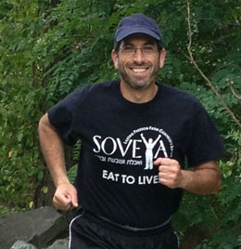
Rabbi Eli Glaser

For years I ran – to the smorgasbord, to the all-you-can-eat buffet, to the front of the line at the deli counter, chasing the tastiest recipe or the biggest meal. And what did all that “exercise” get me? A morbidly obese, 300-pound body.
I was running to eat, practically sprinting into a six-foot hole in the ground, dug by my own fork, knife and greasy spoon. A marathon of misery made up of morsels of passing palatable pleasures, repeatedly reinforced by portions of regret and remorse.
Now, I’m running to live; not just for myself, but for all the people who are still stuck in my old workout routine.
Eleven years ago, I changed my life, gained a lot of clarity, honesty and conviction – and lost 120 pounds.

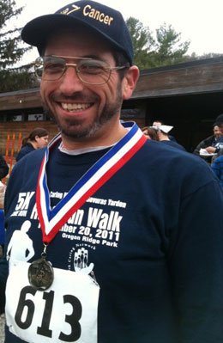
Notice the number I “randomly” received

A few days from now, along with 30,000 of my closest friends, I’ll be running in the Marine Corps Marathon in Washington, D.C. I’m not doing this to try and show off my new-found speed and world-class endurance. I’ll be happy to finish the 26.2-mile course in fewer than 5 ½ hours, which would put me in about 18,905 place (give or take a few hundred).
Basketball and Ultimate Frisbee are my sports of choice. I love the skills and teamwork – not to mention building up a good sweat. But running just for the sake of running was never in my game plan. Until our 15-year old son, Yossi, was diagnosed with a malignant brain tumor in March, 2011. Talk about having your world thrown upside down.
Just a few hours before Shabbat, my wife and son were flown on a medevac helicopter from Baltimore to Children’s National Medical Center in Washington, D.C. for emergency treatment that included brain surgery and five days in the ICU.

After three cycles of chemotherapy in Baltimore and more than 20 rounds of proton-beam radiation treatments in Philadelphia – supplemented by an ongoing anti-cancer nutrition regiment, thank G-d Yossi’s scans are completely clean, as is his bill of health for the future (G-d willing).
We are extremely grateful and humbled by the outpouring of support and prayers we received from around the world, as well as in our incredible community of Baltimore. One local organization in particular, The Jewish Caring Network, literally held our hand, propped up our feet and physically and emotionally guided us through this ordeal.
So two years ago, when I was asked to take part in their annual 5K fundraiser to help support their cause, I felt honored and privileged to participate. There was only one problem; I had never run even one mile before, let alone 3.1 miles – which is the length of a 5K course.
But how could I say no? So I asked a dear friend, Bruce Luchansky, to help “train” me. I had two goals: not to embarrass myself by slowing him down too much, and trying to run three miles without stopping – no matter how long it took.
Remarkably, during our first morning run I accomplished the latter goal, if not the former, but my legs felt like rubber the entire rest of the day. After giving myself enough time to recover, I trained a few more times and actually earned a medal by placing in the top 10 of my age group at the race. Don’t get too excited, though, I think there were only 15 of us total.
But I got the running bug. I started to like running just for the sake of running. It wasn’t as immediately stimulating as hustling down court on a fast break or chasing down a disc in a competitive game of Ultimate Frisbee, but after each run I felt really good. The endorphins were kicking in. I was experiencing the “runner’s high” and building my endurance.
Five kilometers turned into 10, and six-mile runs extended to 12. The first time I ran 13 miles – the length of a half marathon - I was amazed I could cover that distance without stopping. I started to enter races – not with the vision of winning, but to help push myself by competing against others. So far I have met my goals – which are to complete each race and not to finish last.
My main objective in running the marathon is to raise awareness to help reverse the obesity epidemic and to educate our community about proper nutrition, emphasizing the point that anyone can change their life and develop a healthy relationship with food.
This is the time of the Jewish year to put plans into action. We spent hours praying and reflecting during the High Holy Days and perhaps we pledged to “once and for all change our diet and/or start exercising more.” The days and weeks following the holidays are the true testing ground of those commitments. Are they going to be empty words or not?
Proper diet and appropriate exercise are fundamental Jewish tenets. We have a responsibility to care for the precious body G-d gave us. This is a lesson I learned the hard way and now I’m trying to make it easier for others to learn it as well. I hope that my story can help motivate you to take that first, critical step. Nothing is stopping you - and nothing tastes as good as feeling good feels.

Reprinted from this week’s email of Aish.com
Groceries and Greatness
By Rabbi Yechiel Spero

The young man's unusual intelligence and perseverance in his learning captured the attention of the Rosh Yeshiva and the other members of the administration. Perhaps that was why Reb Ezra Attia, the Rosh Yeshiva, was so surprised when the young man did not show up to classes for a number of days. Worried that the boy might be ill, Reb Ezra paid a visit to the boy's home. As Reb Ezra approached the run-down home, he noticed that even in this poor neighborhood of Jerusalem, this house seemed particularly shabby.

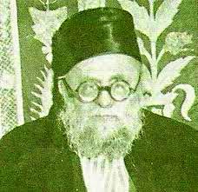
Rabbi Ezra Attia, zt”l (1887-1970)

Reb Ezra knocked lightly on the door and waited. The boy's father came to the door and was embarrassed that the Rosh Yeshivah had come all the way to their house. He asked the Rav why he had come.
Reb Ezra explained his concern, and noticed that the man seemed distraught. "What should I do? I need help in my small grocery store, carrying the merchandise and loading it onto the shelves." Reb Ezra listened patiently but explained that there was nothing in the world more important than Torah. As the conversation continued, each man maintained his position. Reb Ezra finally decided to leave. He thanked the man for his time, and as he walked away he noticed his young talmid standing in the corner of the room. The boy was embarrassed and deeply heartbroken that Reb Ezra had not convinced his father to send him back to yeshivah.

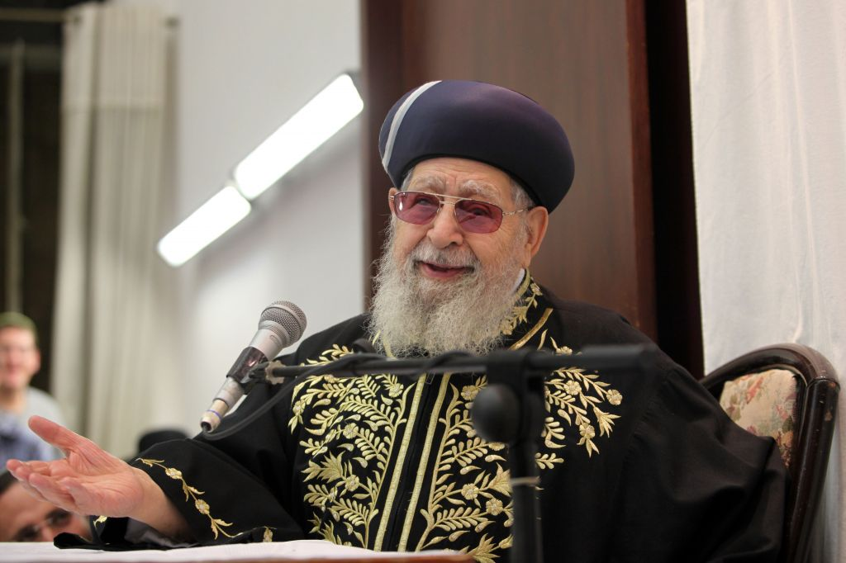
Chacham Ovadio Yosef, zt”l

The next morning the young man's father entered his store, donned his apron, and suddenly noticed someone standing in the corner -- there was Reb Ezra, his son's rebbi, standing in the store, wearing an apron!
He asked Reb Ezra, "what are you doing here, and why are you wearing an apron like one of my workers?" Reb Ezra replied that he had come early and had found his student preparing for the day's work. He informed the boy that he had found someone who was willing to work without pay -- in fact it was the rebbi himself who was reporting for work. "You said you needed someone to help," he explained to the boy's father, "and better that I should help and allow your son to learn. Nothing is more important than your son's learning!"
His point had been made. The father agreed to allow his son to continue learning on the condition that Reb Ezra remove the apron. And that young man excelled in yeshivah. Today he is none other than one of the leaders of Sephardic Jewry, Chacham Ovadiah Yosef!

Reprinted from “Touched by a Story 2” by Rabbi Yechiel Spero, published by ArtScroll, pages 30-31: And it was Chacham Yosef whose levayah in Yerushalayim earlier this month attracted almost one million mourners from all over Eretz Yisroel.

